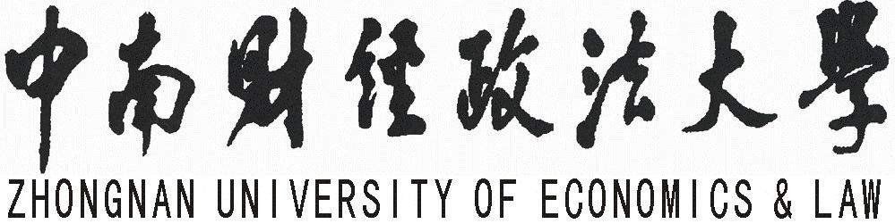

Schooling Certificate

Name |  | Gender |  | Nationality
Student No. |  | Native place
School |  | Major
Class |  | ID  Number

This is to certify that the student mentioned above is minoring in Finance in Zhongnan University of Economics & Law from March 2017 till now. She has completed the credits required by the teaching plan, and she will be qualified to get the Bachelor’s degree of Economics in June 2019.
Hereby certify!

Zhongnan University of Economics & Law
School of Finance
4 September 2018

